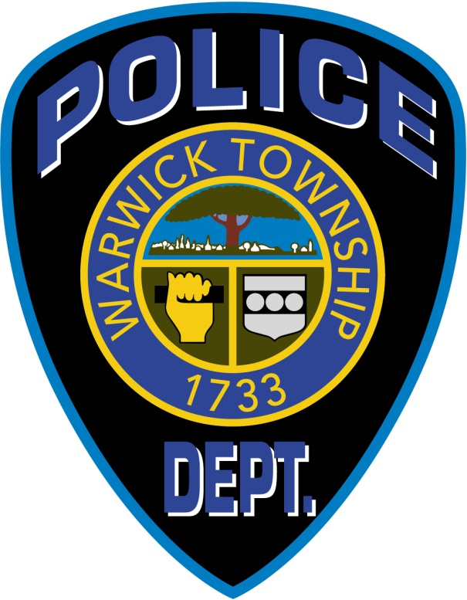

1733 Township Greene
Jamison, PA 18929
215-343-6102

The Warwick Police Department, located in Central Bucks County, is accepting resumes for the position of Probationary Police Officer. Our current authorized strength is 18 sworn officers. The Department sponsors several specialty units, including Investigations, Traffic Safety, Crime Scene Investigation, and SWAT.
Officers enjoy excellent salary and benefits. Starting pay for 2023 is $68,608.85 per year, with incremental increases to $113,807.12 after five years (before adjustments). We offer a full health care package, pension and retirement benefits, as well as bonuses for college degrees and course work.
Our Department prides itself on providing the highest level of service to our community. We operate in a team environment, and are looking for exceptional candidates with a proven track record of success.
Candidates must possess:
- PA Act 120 certification, or attending an academy now;
- A college degree or military veteran status.
Resumes will be accepted through PoliceApp.com. There is no fee to apply. We will be accepting the first 30 resumes.

