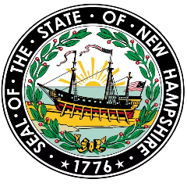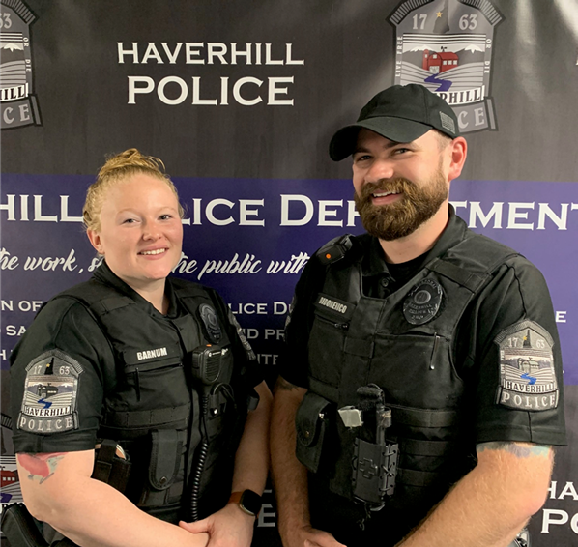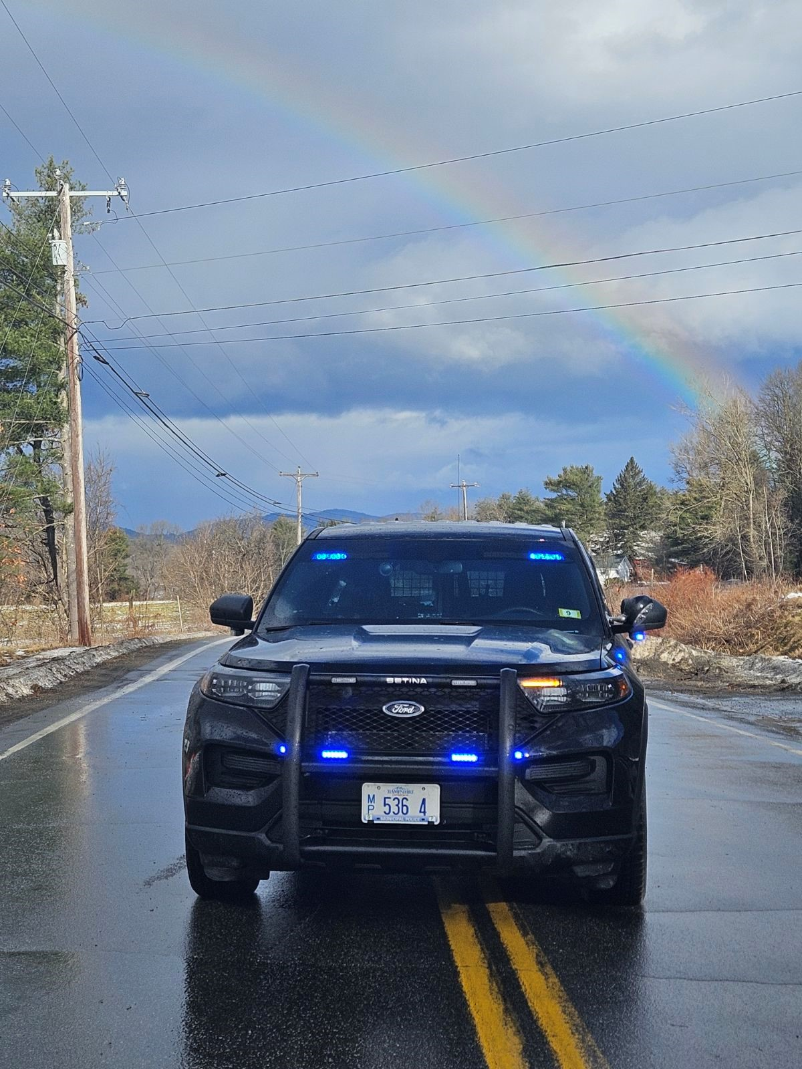

MAKING A DIFFERENCE

STARTS HERE

**Training Opportunities**

**Starting Pay $55,000**

**FULL-TIME POLICE OFFICER MINIMUM QUALIFICATIONS**

* Team Oriented
* Ability to work among diverse cultures
* Must be at least 21 years of age
* Possess a High School diploma
* Possess a valid driver’s license
* Be a US Citizen
* Pass a physical agility test
* Good communication skills

**Make a positive impact and join the Team**

* 4 on / 3 off Schedule
* Job Security
* Detail Rate $55-65
* Skill Development
* Comprehensive Healthcare
* Competitive Pay
* Group 2 Retirement
* Relaxed Tattoo Policy

**Haverhill NH**

**Police Department**

**is now**

**-Hiring-**

**Police Officers**